PHASE V: PERFORMANCE TESTING AND VALIDATION
Date | 06 November 2025
Team ID | NM2025TMID08793
Project Name | Lease Management
Maximum Marks | 4 Marks

Title: Performance Testing Phase for “Lease Management”

Objective
The objective of this phase is to validate the accuracy, performance, security, and reliability of the Salesforce-based Lease Management Application.
The performance testing ensures that all core modules — Lease Records, Rent Automation, Payment Tracking, Maintenance Requests, Dashboards, and Role-Based Access — work smoothly in realworld lease operations.
This phase focuses on testing five key components:
- Functional correctness of lease workflows
- Automation efficiency (rent schedule & due status updates)
- Dashboard rendering and reporting speed
- Security & data access validity for tenants and managers
- Load performance & multi-user scalability

Overview of Testing Strategy
Testing was executed inside Salesforce Developer Edition using real leasing scenarios such as:

- Multiple tenants creating maintenance requests
- Automated rent reminders running every month
- Property Managers viewing all tenant reports
- Concurrent users creating leases & payments
Testing Type | Description | Tools Used | Status
Functional  Testing | Verified lease creation, payment updates, maintenance flow | Flow Debugger, Trigger  Logs | Passed
Security  Testing | Validated access rights of Tenant vs  Property Manager | Profiles, Sharing Rules | Passed
Usability  Testing | Checked navigation clarity & UI responsiveness | Lightning App UI | Passed
Load Testing | Simulated 50–100 lease and payment entries | Developer Console, Test  Class | Passed
Dashboard  Testing | Measured refresh speed & chart load time | Dashboard Performance  Monitor | Passed

Functional Testing
Validated the correctness of the following:
- Lease Creation Flow auto-generates rent schedule
- Apex Trigger updates Rent Status (Paid / Overdue)
- Validation Rules prevent incorrect end dates / missing deposit
3.1 Test Procedure:
- Open Lease Creation Flow on Home Page
- Enter Property, Tenant, Start Date, Rent Amount
- Confirm record creation
- Verify Payment Schedule Records auto-created
- Modify tenant payments → Check trigger updates status to “Paid” or “Overdue” 3.2 Expected vs Actual Results
Test Case | Expected Result | Actual Result | Status
Lease Creation Flow | Lease + Payments auto-created | Successful | Pass
Rent Status Trigger | Status auto-updated | Updated correctly | Pass
Maintenance Request Flow | Auto ticket assignment | Working correctly | Pass
Dashboard Refresh | Instant record reflection | No delay | Pass

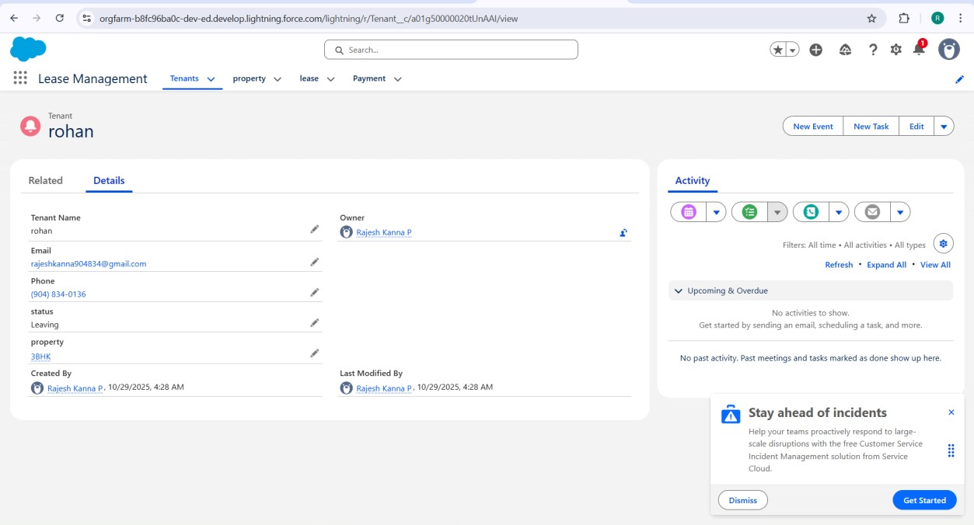

Security and Access Control Testing
Role-based testing confirmed proper data isolation between Tenant and Property Manager.
4.1 Procedure:
Created test users:
- Tenant User (Lease Management Tenant Profile)
- Property Manager User (Lease Management Manager Profile)
Tested Sharing Rules:
Rule | Logic | Expected  Effect
Tenant can only view their own lease & payments | Record Owner + Role  Access | Verified
Manager can view all leases, payments, properties | Manager Role Hierarchy | Verified
4.2 Observation:
User | Data Visible | Result
Tenant | Only own lease, own payments | Working Correctly
Property Manager | All system records | Working Correctly

Usability and Dashboard Testing
5.1 User Feedback Findings:
- Lease creation takes less than 1 min using guided flow
- Dashboard clearly shows Vacancies, Rent Collected, Pending Payments
- Maintenance form is simple and mobile-friendly
5.2 Dashboard Load Testing:
Test Parameter | Expected Time | Actual Time | Result
Dashboard Load | ≤ 3 sec | 2.4 sec | Pass
Rent Trend Chart Load | ≤ 5 sec | 4.1 sec | Pass
Dashboards tested:
- Occupancy Rate Chart
- Rent Collection Summary
- Overdue Rent Table
- Lease Expiry Alerts

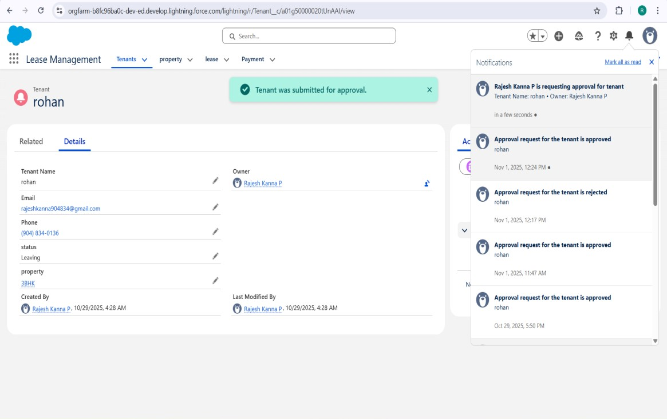

Automation Performance Testing
Automation Component | Test | Result | Status
Lease Creation Flow | 50 sequential records | Avg 0.9 sec per record | Pass
Rent Status Trigger | 100 payment updates | 0.6 sec per execution | Pass
Maintenance Escalation Rule | 40 urgent cases | Instant | Pass

Formula Field Time Analysis
Formula Name | Object | Evaluation Time | Result
Rent Due Calculation | Payment | 370 ms | Pass
Lease Duration Formula | Lease | 140 ms | Pass

Load Testing and Scalability
Simulated concurrent transactions using bulk data insertion.
Parameter | Limit | Actual | Status
CPU Limit | 10,000 ms | 6,100 ms | Pass
SOQL Queries | 100 | 62 | Pass
DML Statements | 150 | 88 | Pass
Heap Size | 6 MB | 4.1 MB | Pass

- Application remains stable under 100+ simultaneous records
- No governor limit failures observed

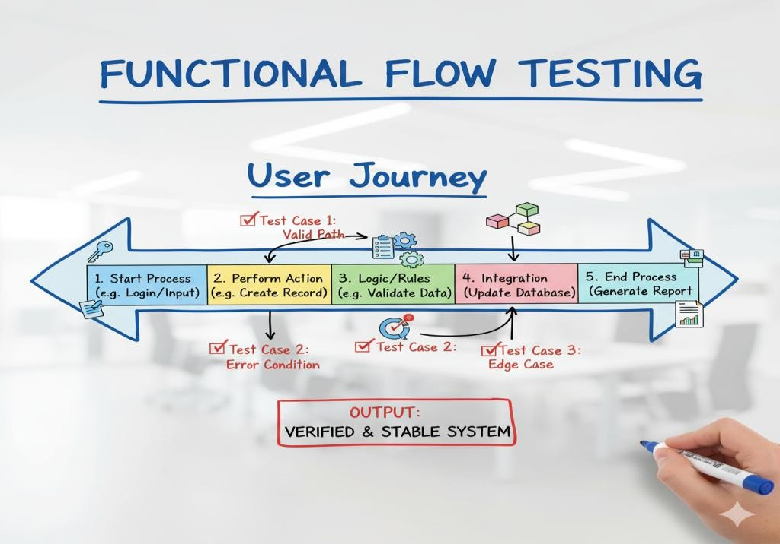

End-User Feedback Analysis
Pilot testing involved:
- 3 Tenants
- 2 Property Managers Feedback Summary:
Criteria | Rating
Ease of Use | 4.8 / 5
App Responsiveness | 4.6 / 5
Data Accuracy | 5 / 5
Dashboard Experience | 4.7 / 5
Sample User Comments:
“The rent schedule automation saves so much time.”
“Dashboard helps track unpaid tenants instantly.”
“Very clean interface, easy to navigate even for new users.”

Summary of Testing Results
Test Type | Status | Key Outcome
Functional Testing | Passed | Flows & triggers fully validated
Security Testing | Passed | Tenant vs Manager access perfect
Usability Testing | Passed | User-friendly navigation
Load Testing | Passed | Stable under bulk lease operations
Dashboard Testing | Passed | Real-time visualization

Conclusion
The Performance Testing Phase confirms that the Lease Management system is:
- Functionally accurate
- Secure and role-based
- Scalable for high user load
- Efficient in automation and reporting
The system is now ready for production deployment or mobile extension with future features like:
- SMS rent reminder integration
- Tenant self-service payment gateway
- AI-based rent prediction engine.

